**6.1 Overview of User Interface**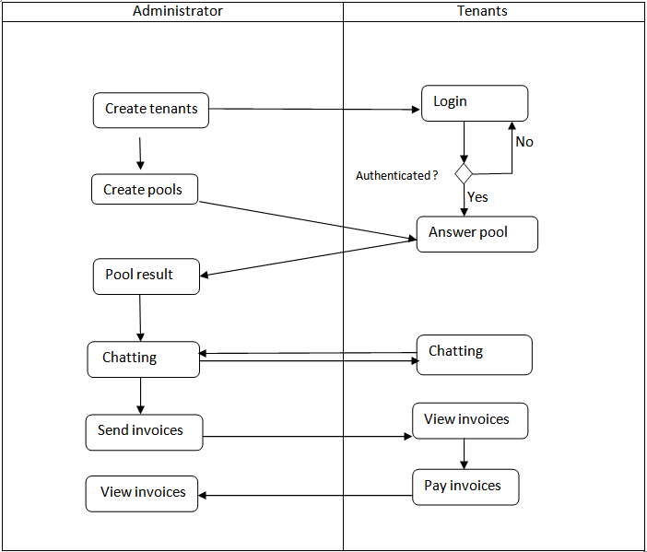

**Answer pool** provides the oportunity for the user to respond to different questions with one or more answears.

**Chatting** is used by users for direct messaging the administrator or another user.

**View invoices** makes the users able to see their payments whenever they are updated.

**Pay invoices** is the functionality that most users dislike. This one is used by them for paying their taxes.

**6.2 Screen Images**

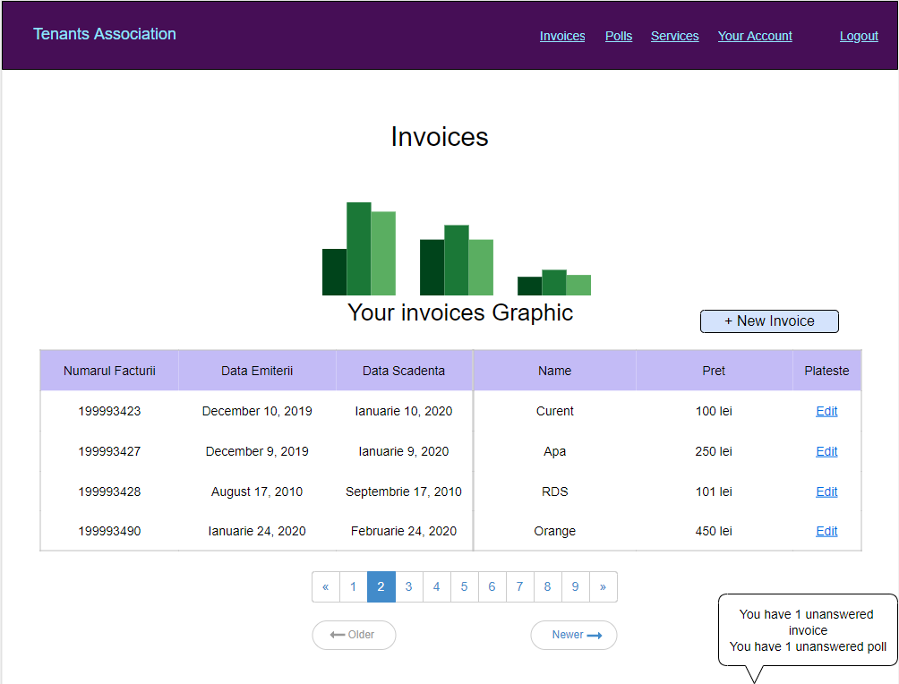

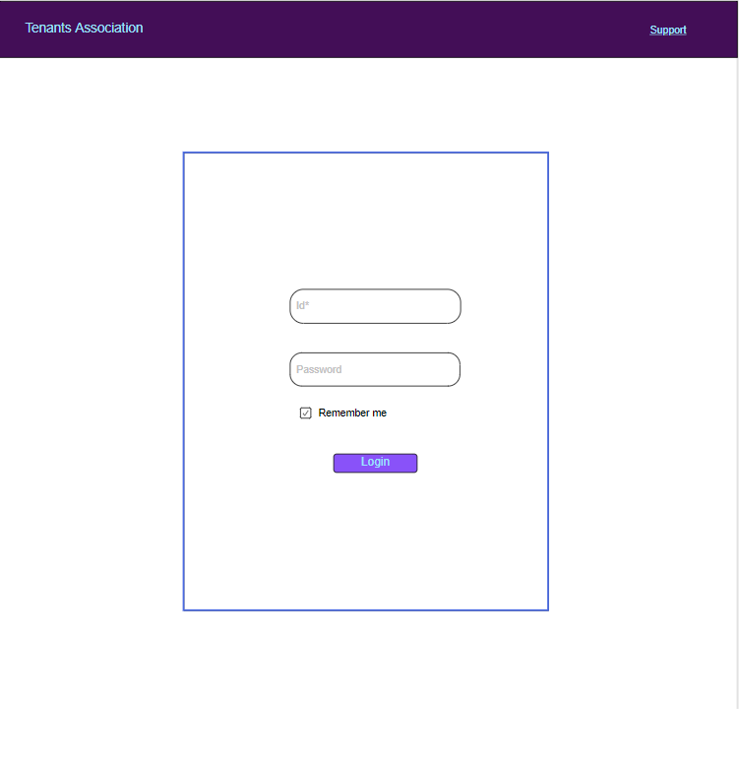

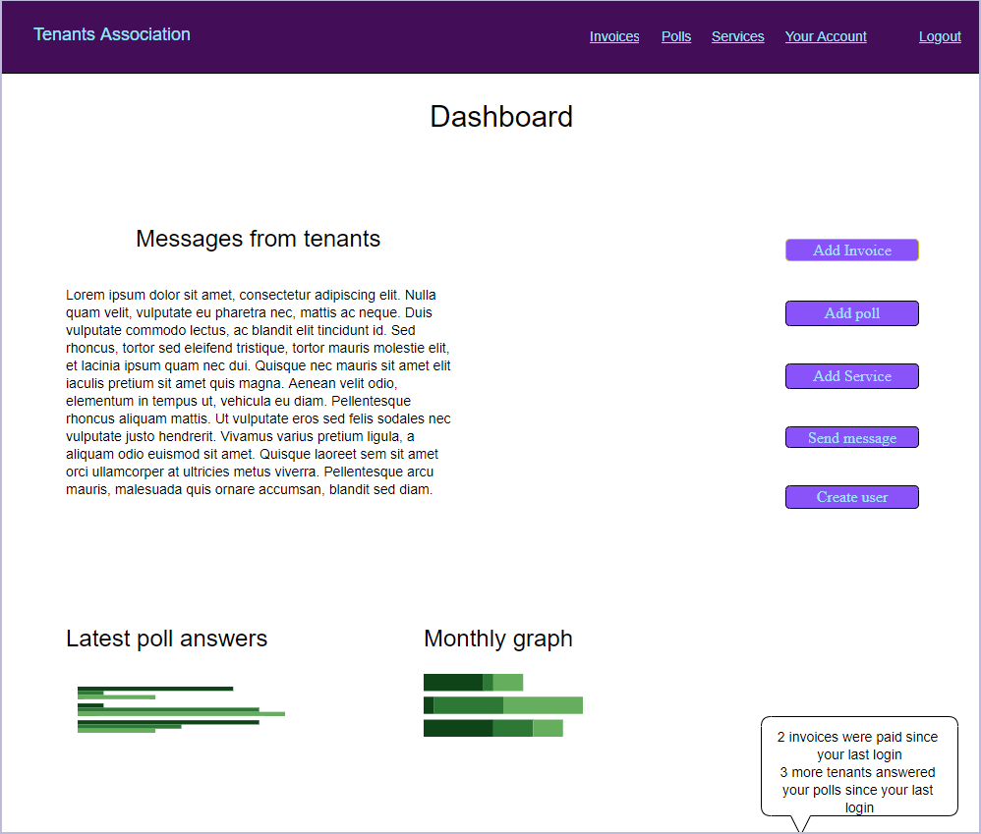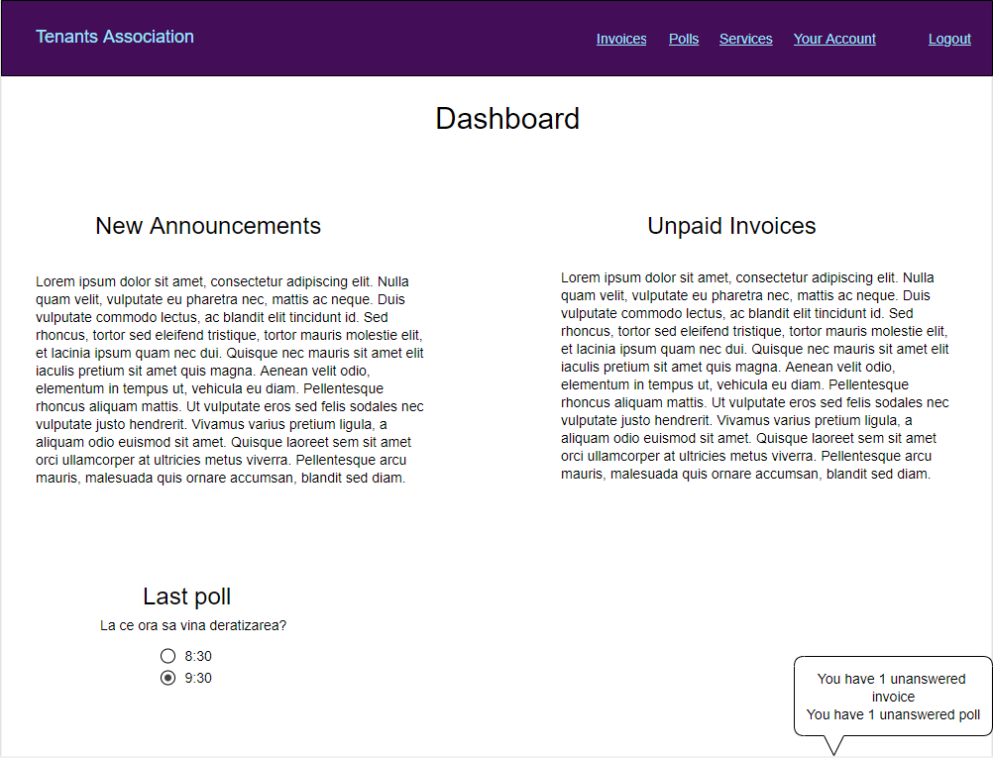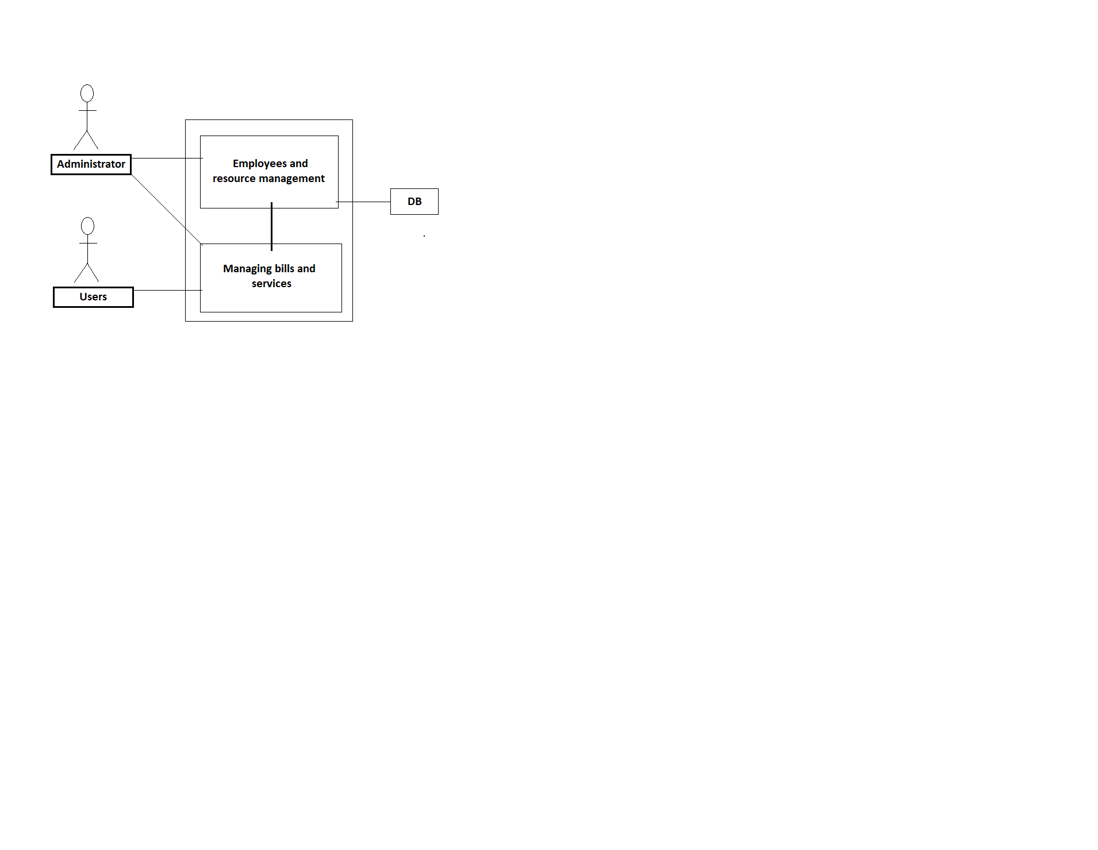

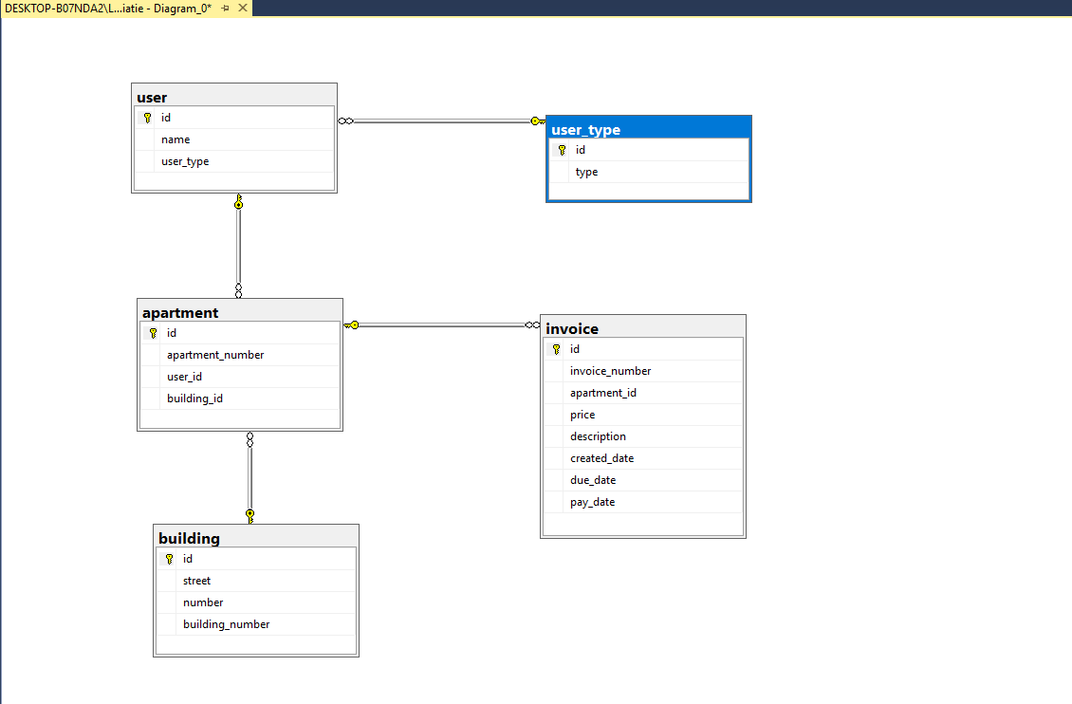

**6.3 Screen Objects and Actions**

**-Invoices**

The invoices graphs are a more detailed way of showing users all the details about their payments. They can see their series number, prices, names, create date and due date of the payments.

**-Login-Mockup**

Represents a specific window that provides the user with the option to authenticate. It has a „login” text box and „pasword” and the option to remember the user.

**-Mockup-Admin-Dashboard**

The dashboard contains the messages from users. It also has multiple options such as „Add invoice”, „Add poll”, „Add Service”, „Send message”, „Create user”.

**-Mockup-User-Dashboard**

This dashbord shows all the notifications and news that the administrator provides including also the polls.